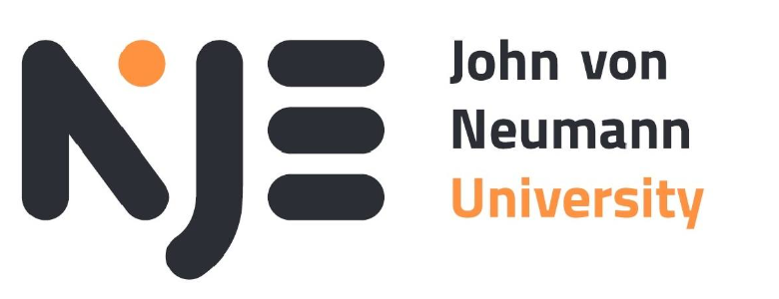

Java Applications Seminar Homework
SpringBoot project

Prepared by: Khaliun Tamir, Enkhjee Gantulga
Neptun Code: EU2XJ4, CPY45Q
University: John von Neumann University
Faculty: GAMF Faculty of Technology and Informatics
Date: November 30th, 2025

Table of Contents
- Introduction
- Technologies Used
- Task 1 – Free Responsive Theme
- Task 2 – Authentication System
- Task 3 – Main Menu
- Task 4 – Database Menu
- Task 5 – Contact Form
- Task 6 – Messages Menu
- Task 7 – Charts Menu
- Task 8 – CRUD Menu
- Task 9 – REST API + cURL + Postman
- Task 10 – Admin Menu (Role-based Security)
- Database Schema
- Routes & Navigation
- GitHub Repository

1. Introduction
This documentation describes the TownsApp project developed for the Web Programming Seminar using:
- Spring Boot
- Thymeleaf
- Spring Security
- MySQL database
- Bootstrap Nova Theme
The application includes authentication, database operations, charts, CRUD, REST API, and an Admin dashboard.
All tasks have been implemented according to seminar requirements.

2. Technologies Used
Technology | Purpose
Spring Boot 4 | Backend framework
Thymeleaf | Template engine
Spring Security | Authentication + Authorization
MySQL (phpMyAdmin) | Database
JPA / Hibernate | ORM
Bootstrap 5 Nova Theme | UI styling
Lombok | Model boilerplate reduction
cURL / Postman | REST API testing

3. Task 1 – Free Responsive Theme
The Bootstrap Nova Admin Theme was selected for the entire UI of the project.
Modifications included:
- Integration into Thymeleaf template structure
- Navbar and footer added as reusable fragments
- Brand styling changed to “TownsApp”
- Added names + Neptun codes on the main page

4. Task 2 – Authentication System
The app contains a complete login + registration system.

Features:
✔ User registration
✔ BCrypt password hashing
✔ Login & logout
✔ Spring Security Session
✔ Roles: VISITOR, USER, ADMIN
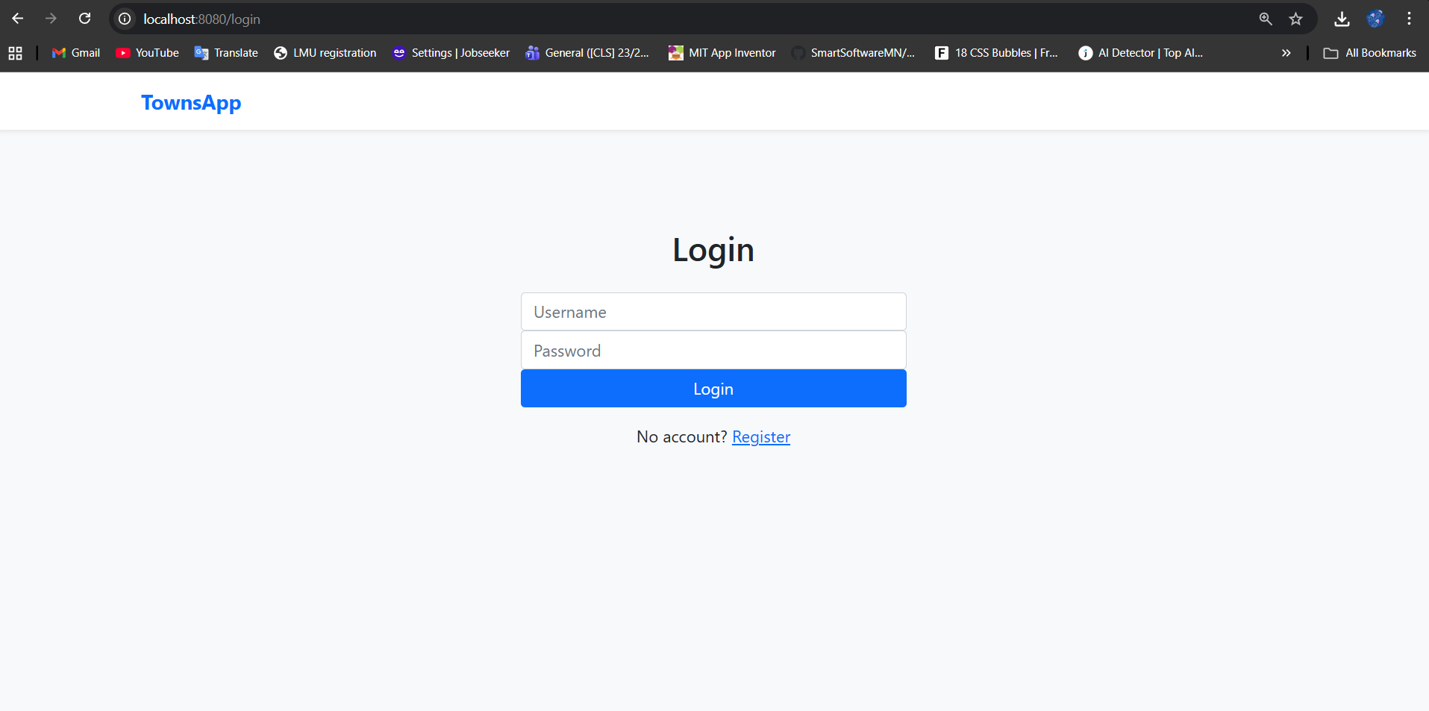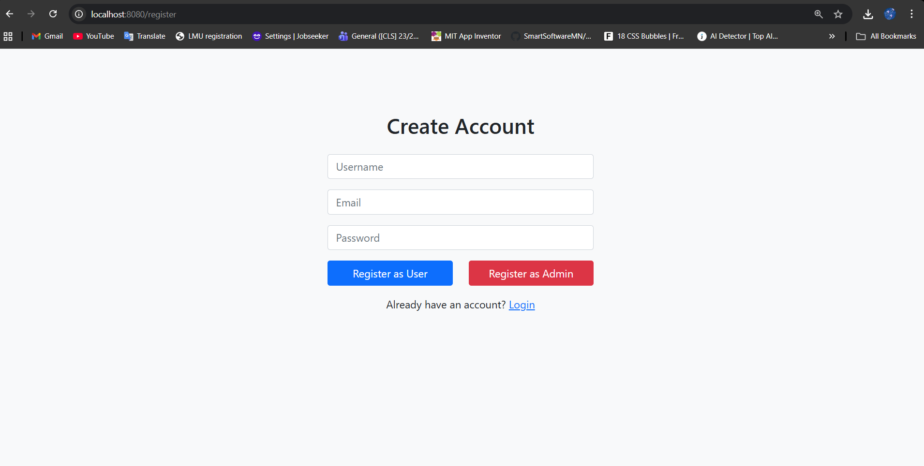

5. Task 3 – Main Menu
The main page displays a welcoming UI:
- “Welcome to TownsApp Seminar Project”
- Button linking to Database menu
- Created By: Khaliun & Enkhjee + Neptun Codes
Menu visibility is dynamic based on user roles.
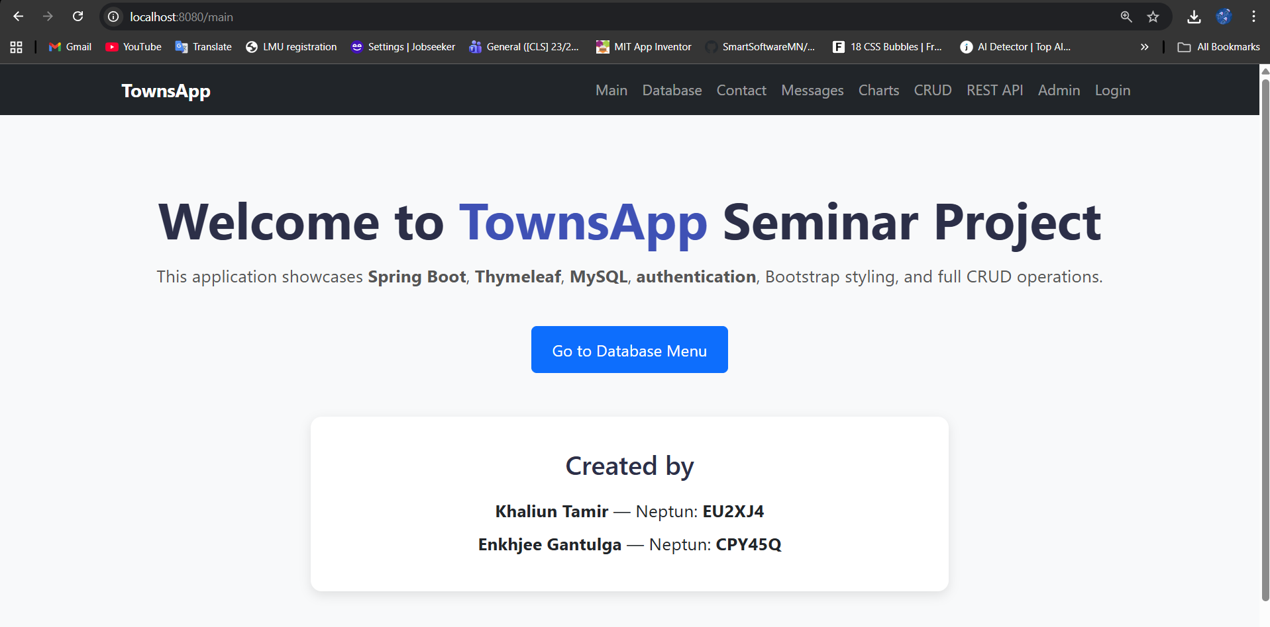

6. Task 4 – Database Menu
The Database Menu lists three tables:
✔ Counties
✔ Towns
✔ Populations
Data is fetched from MySQL using:
CountyRepository
TownsRepository
PopulationsRepository

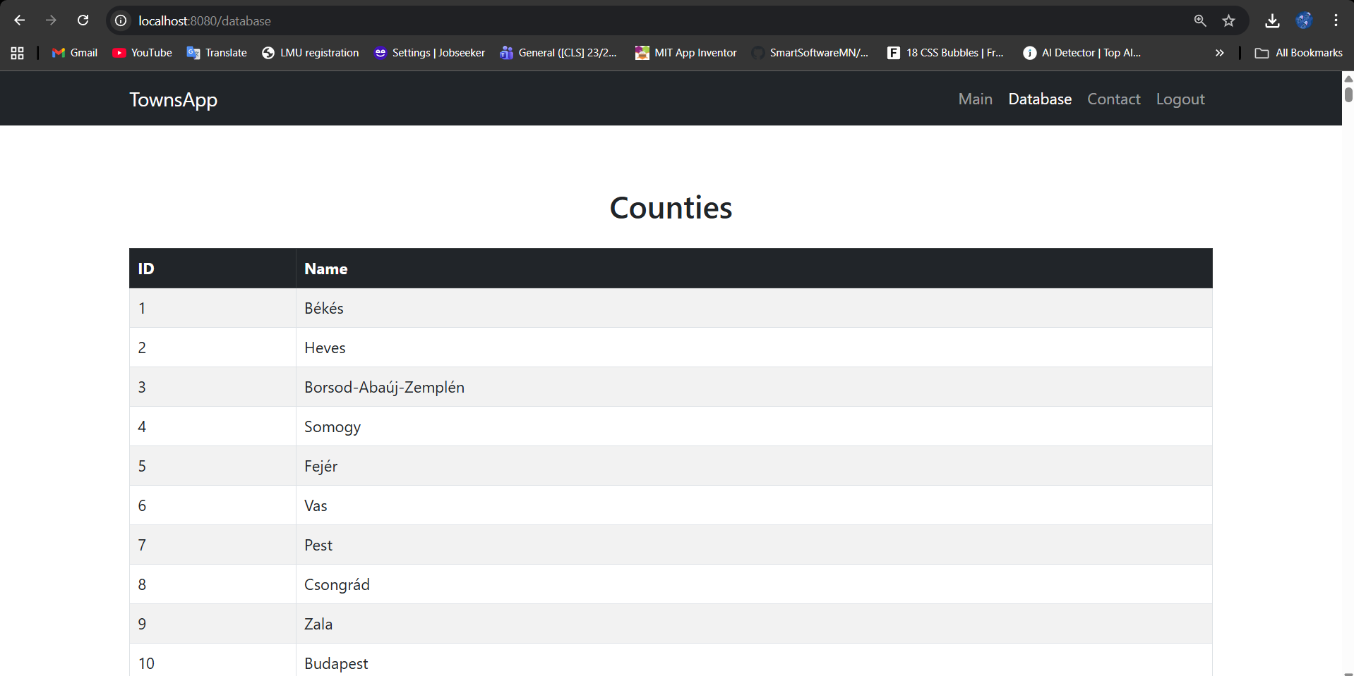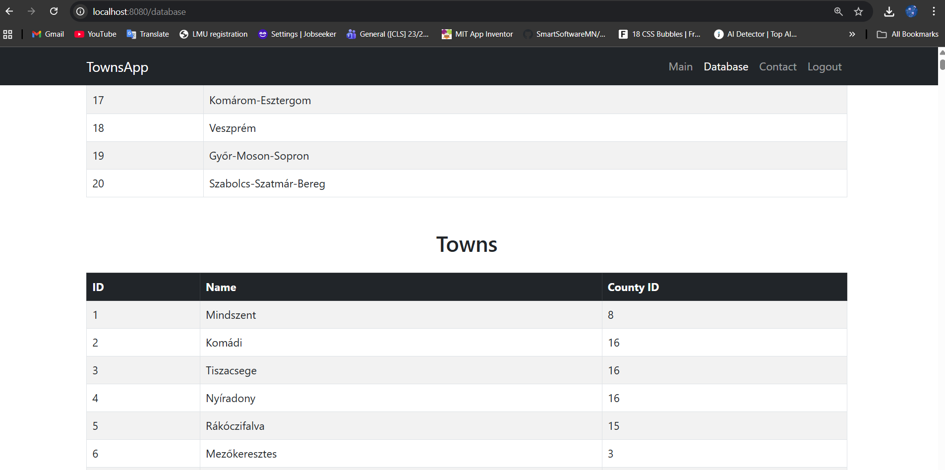

7. Task 5 – Contact Form
A contact form was implemented containing:
- Name
- Email
- Message
Form submits to /contact.
Messages are saved into database table message.
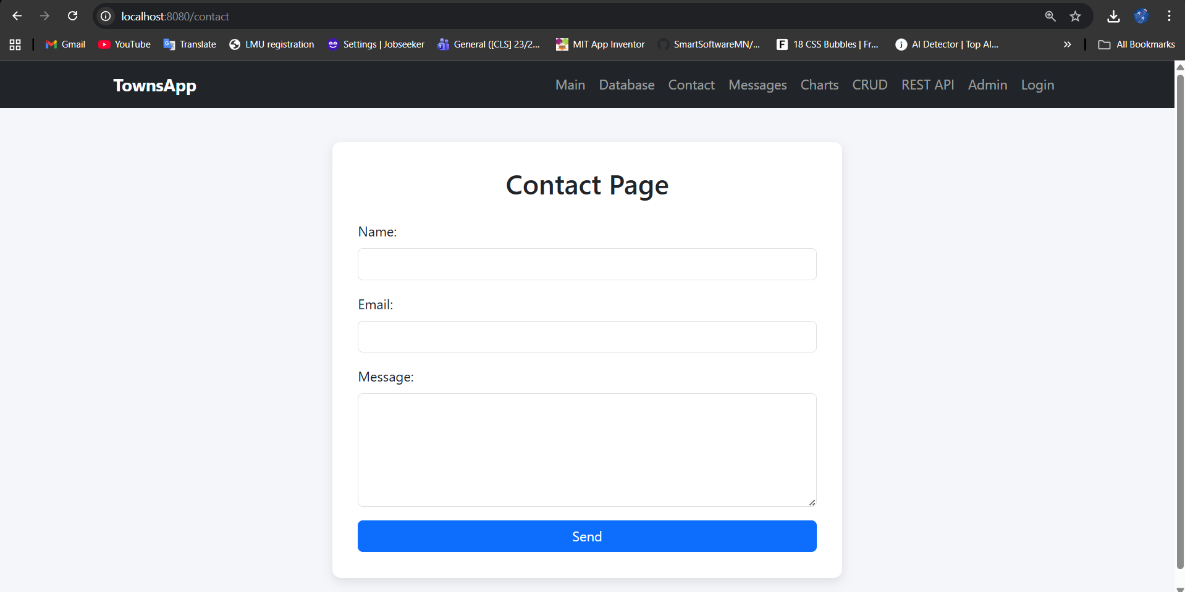

8. Task 6 – Messages Menu
This page displays all messages sent from the contact form.
Features:
✔ Only visible to authenticated users
✔ Sorted by ID
✔ Styled using Bootstrap Table

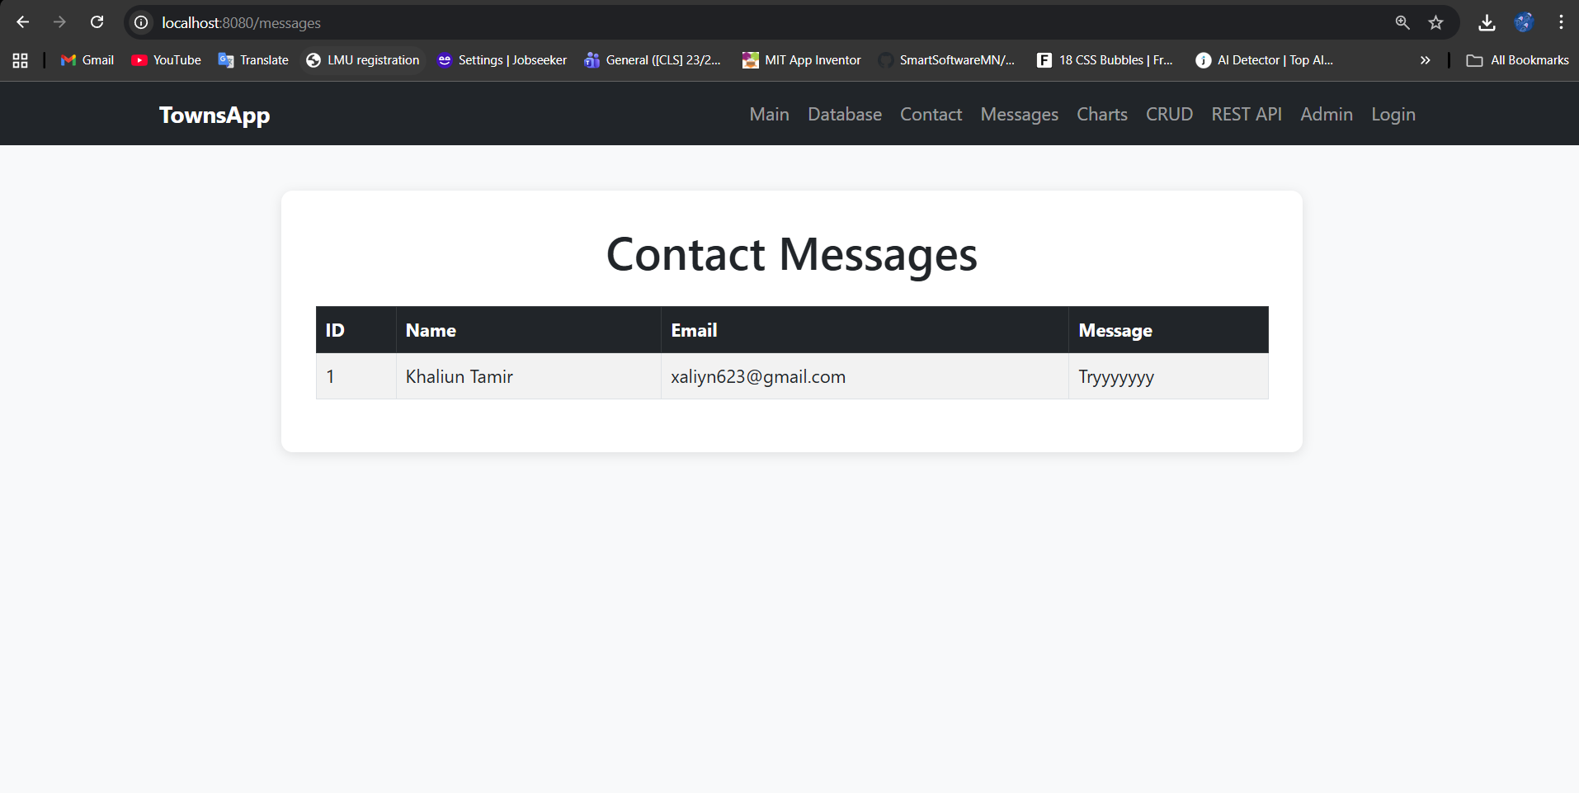

9. Task 7 – Charts Menu
Charts were created using Chart.js.
Displayed:
- Population by towns
- Population distribution over years
Controller: ChartController.java
Template: charts.html
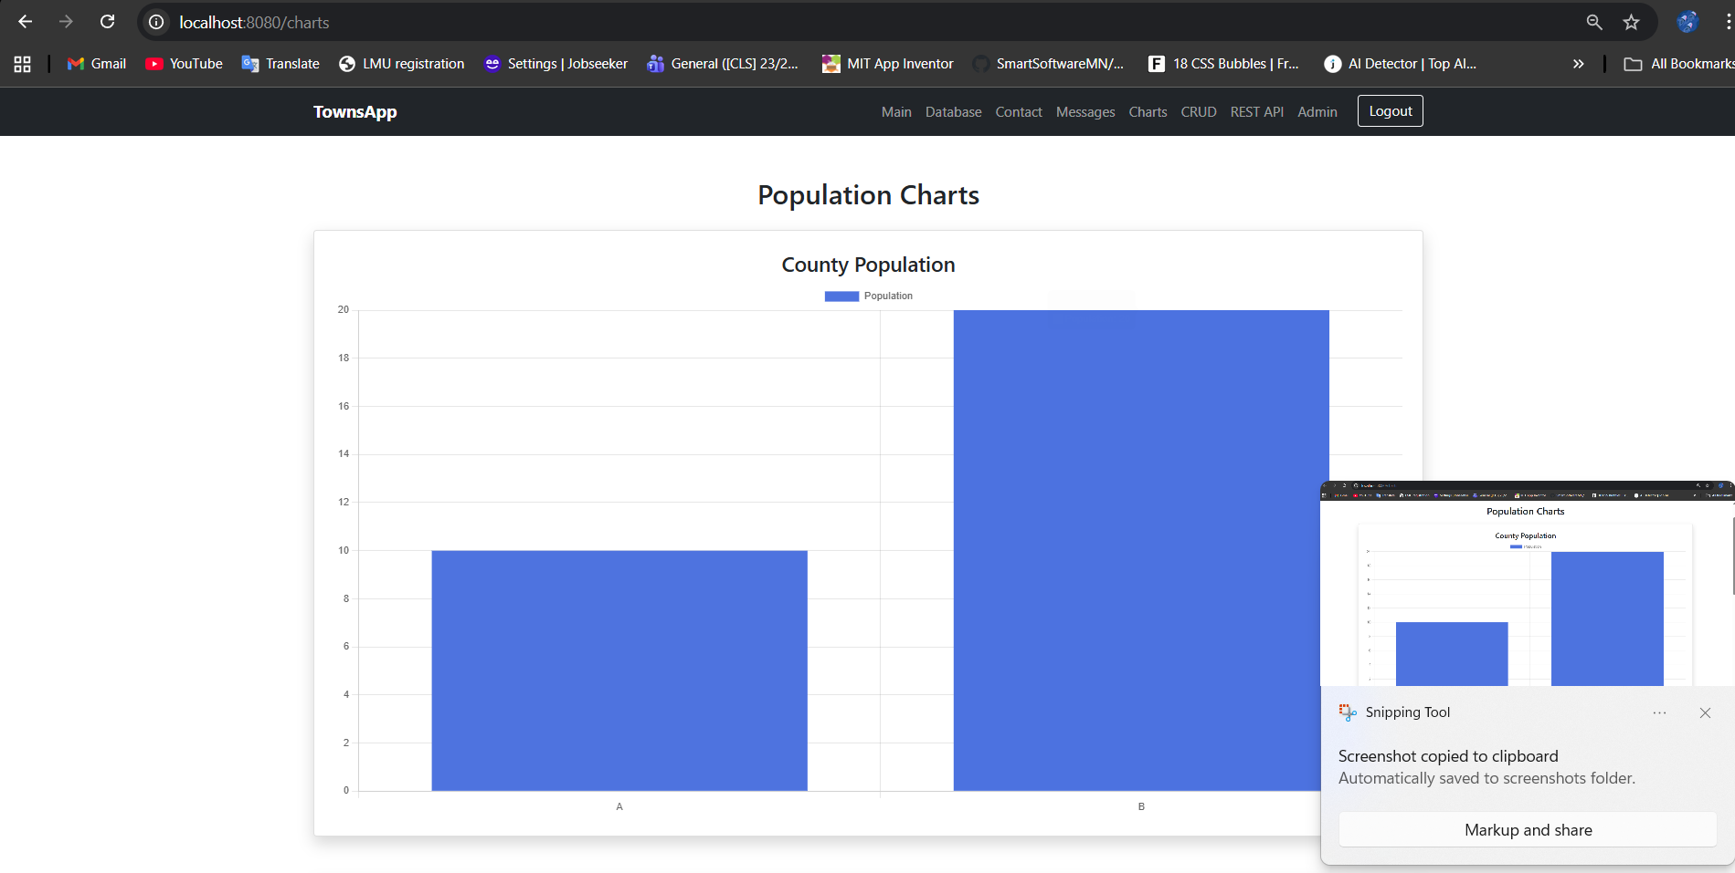
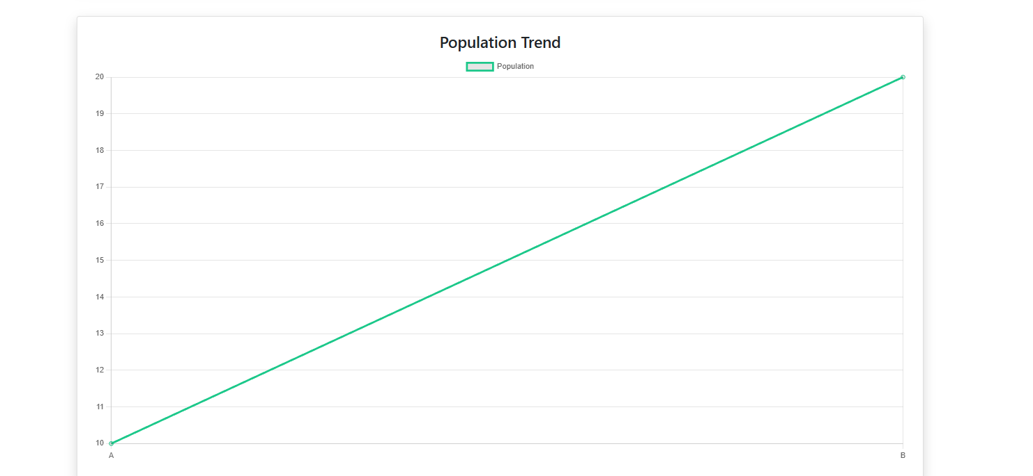

Task 8 – CRUD Menu
A full CRUD interface for the Population table:

Functions:
✔ Add new population record
✔ Edit existing population
✔ Delete record
✔ List all items
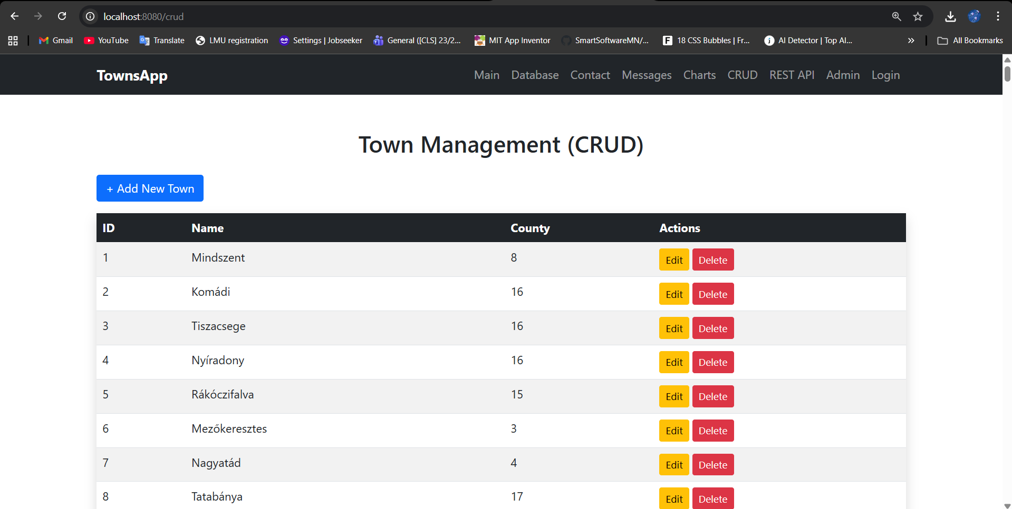

11. Task 9 – REST API + cURL + Postman

API Endpoints
Endpoint | Description
GET /api/towns | Returns all towns
GET /api/counties | Returns all counties
Controller:
ApiController.java

cURL Test (Windows PowerShell)
PowerShell requires curl.exe, so use:
curl.exe http://localhost:8080/api/towns

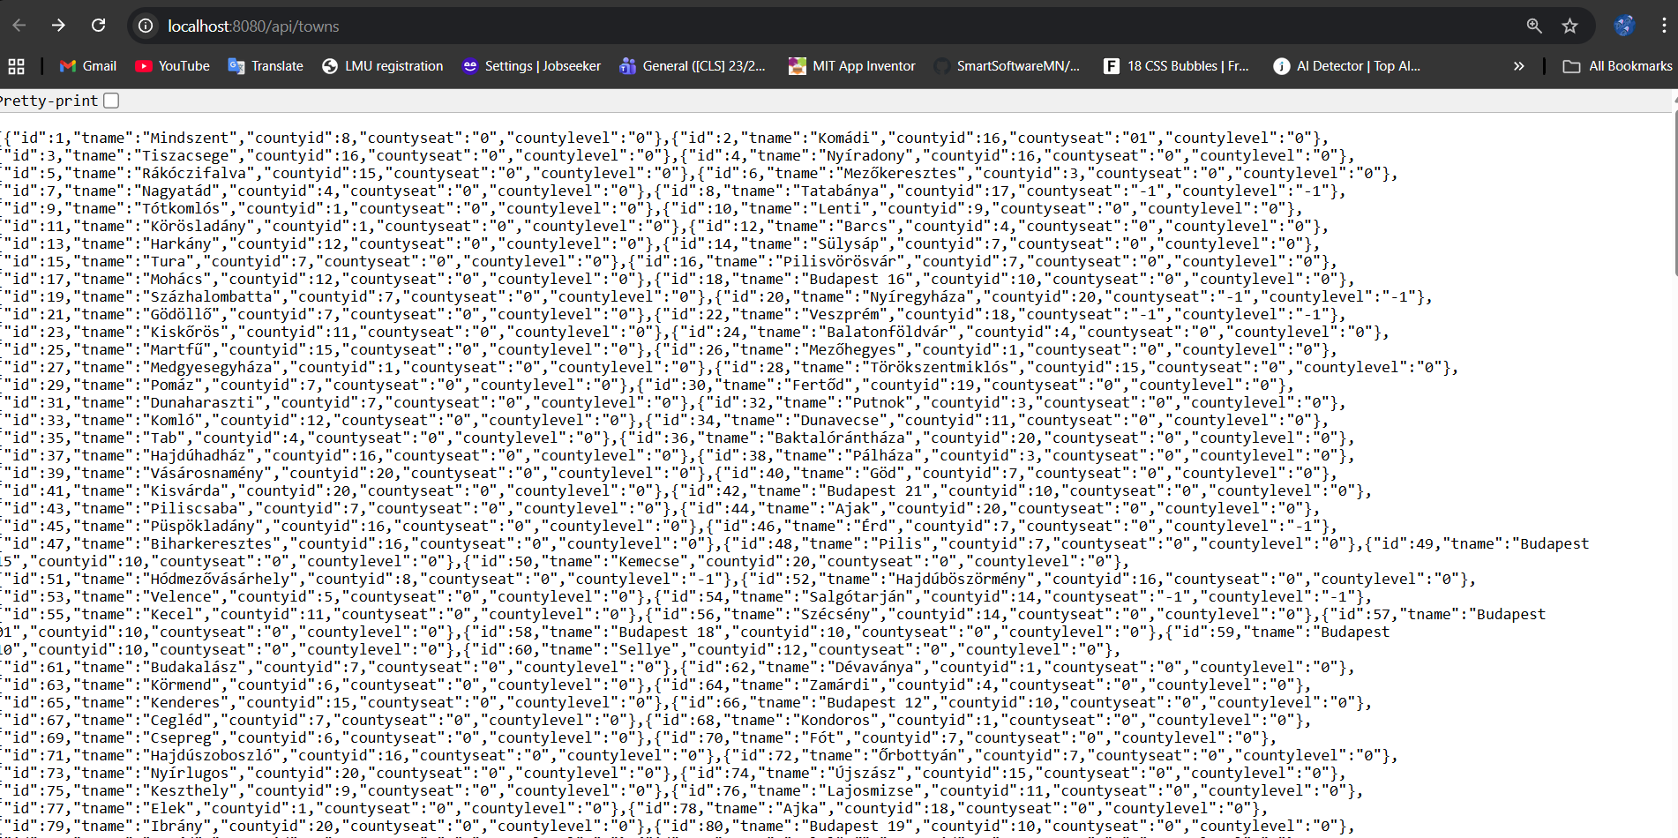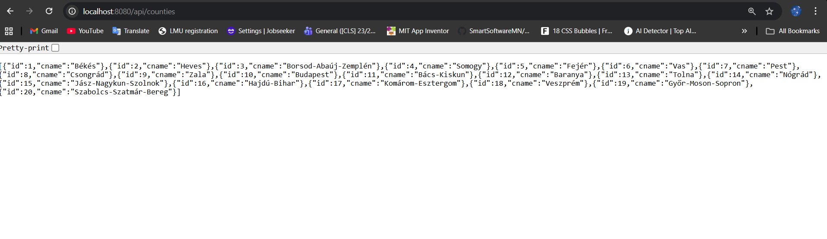

Postman Test
GET → http://localhost:8080/api/towns
Displayed JSON list of all towns.
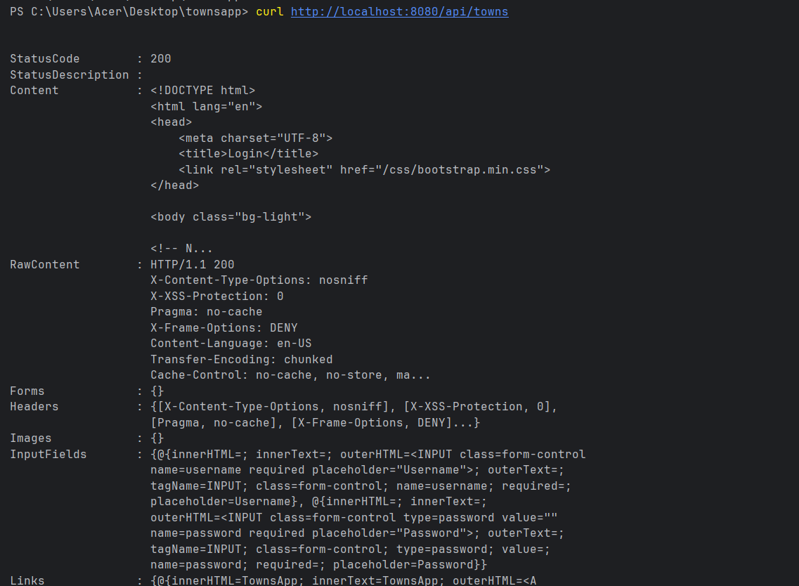

Task 10 – Admin Menu (Role-based Security)
Admin pages are accessible only for users with role:
ROLE_ADMIN
Protected route:
/admin
Implemented with:
@PreAuthorize("hasRole('ADMIN')")
Admin page includes:
- Admin dashboard
- Message: “Only Admin can see this page.”
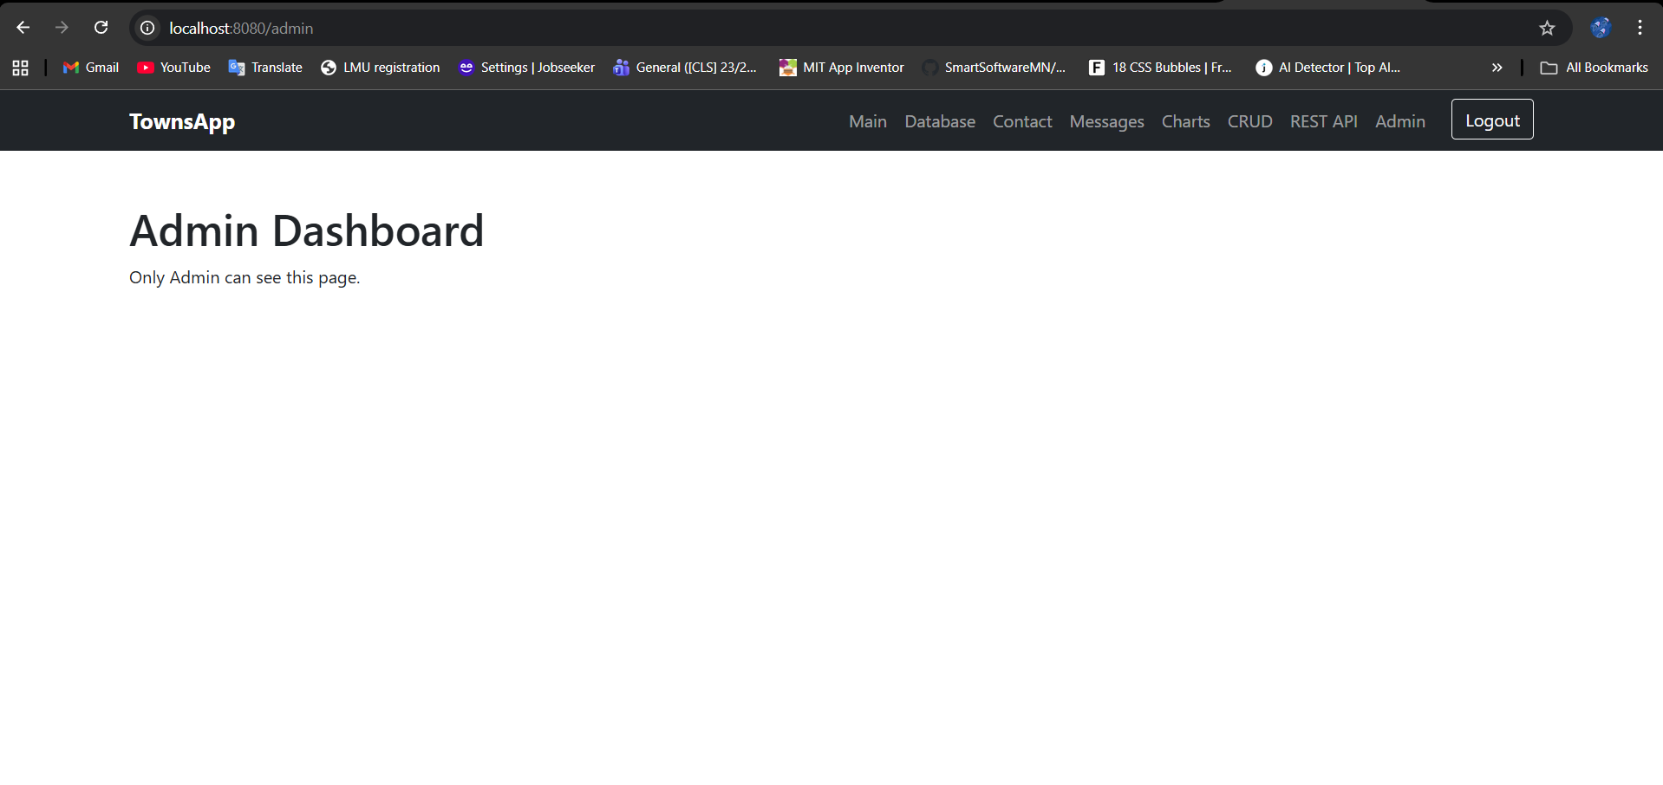

13. Database Schema
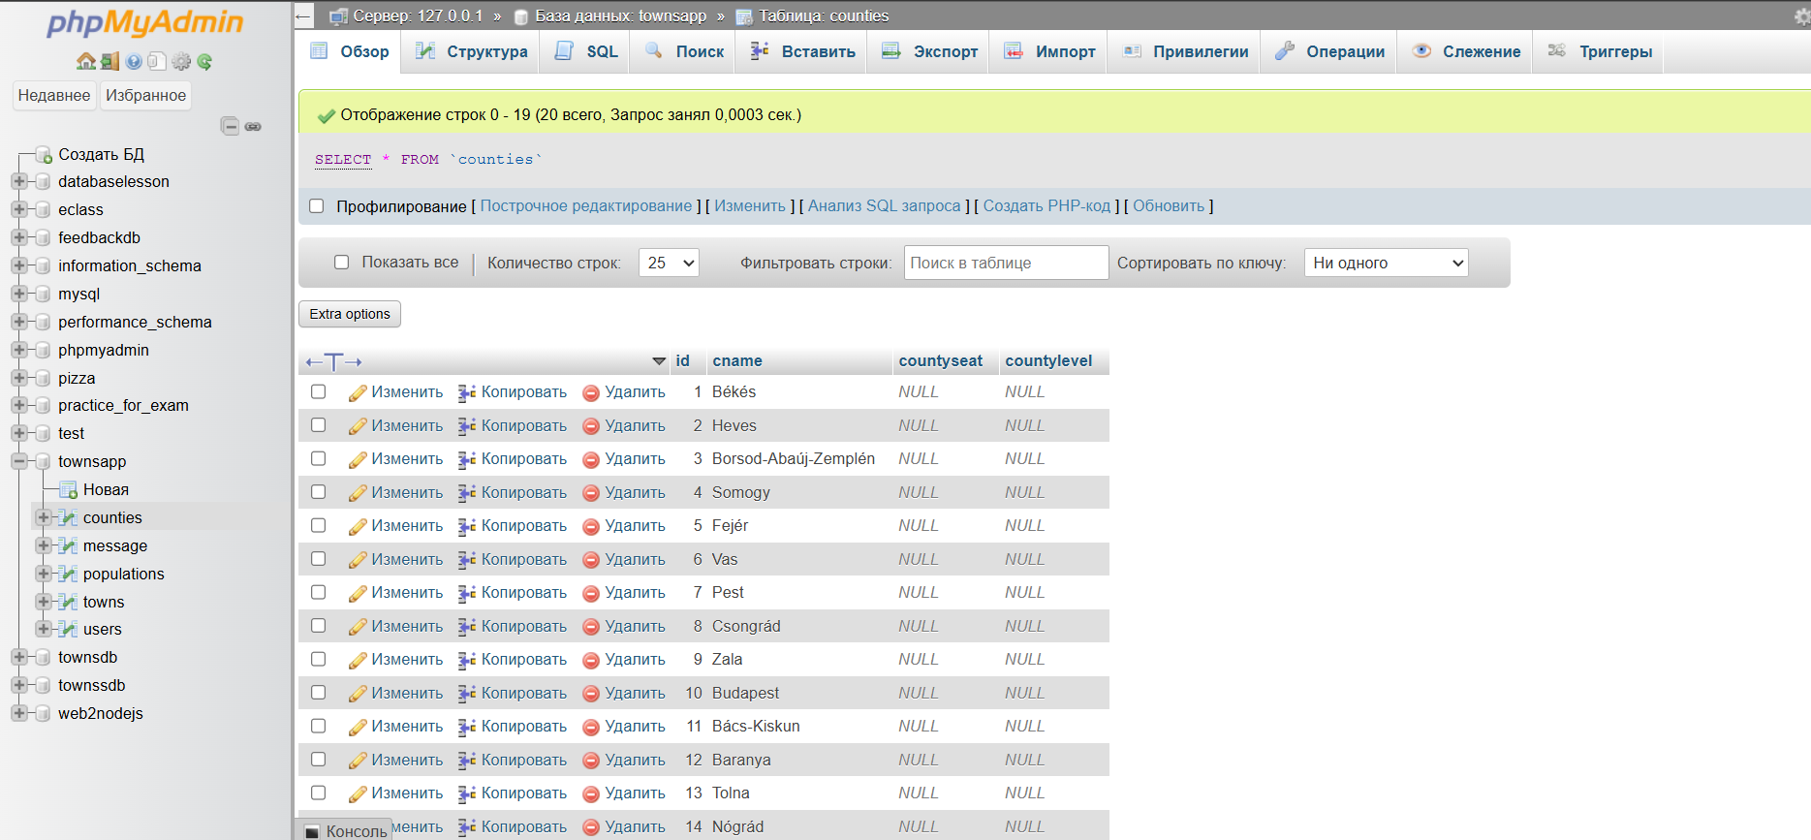

14. Routes & Navigation
Route | Description
/main | Home page
/login | User login
/register | Register
/database | Database menu
/contact | Contact form
/messages | View messages
/crud | CRUD operations
/charts | Chart visualizations
/api/** | REST API
/admin | Admin dashboard
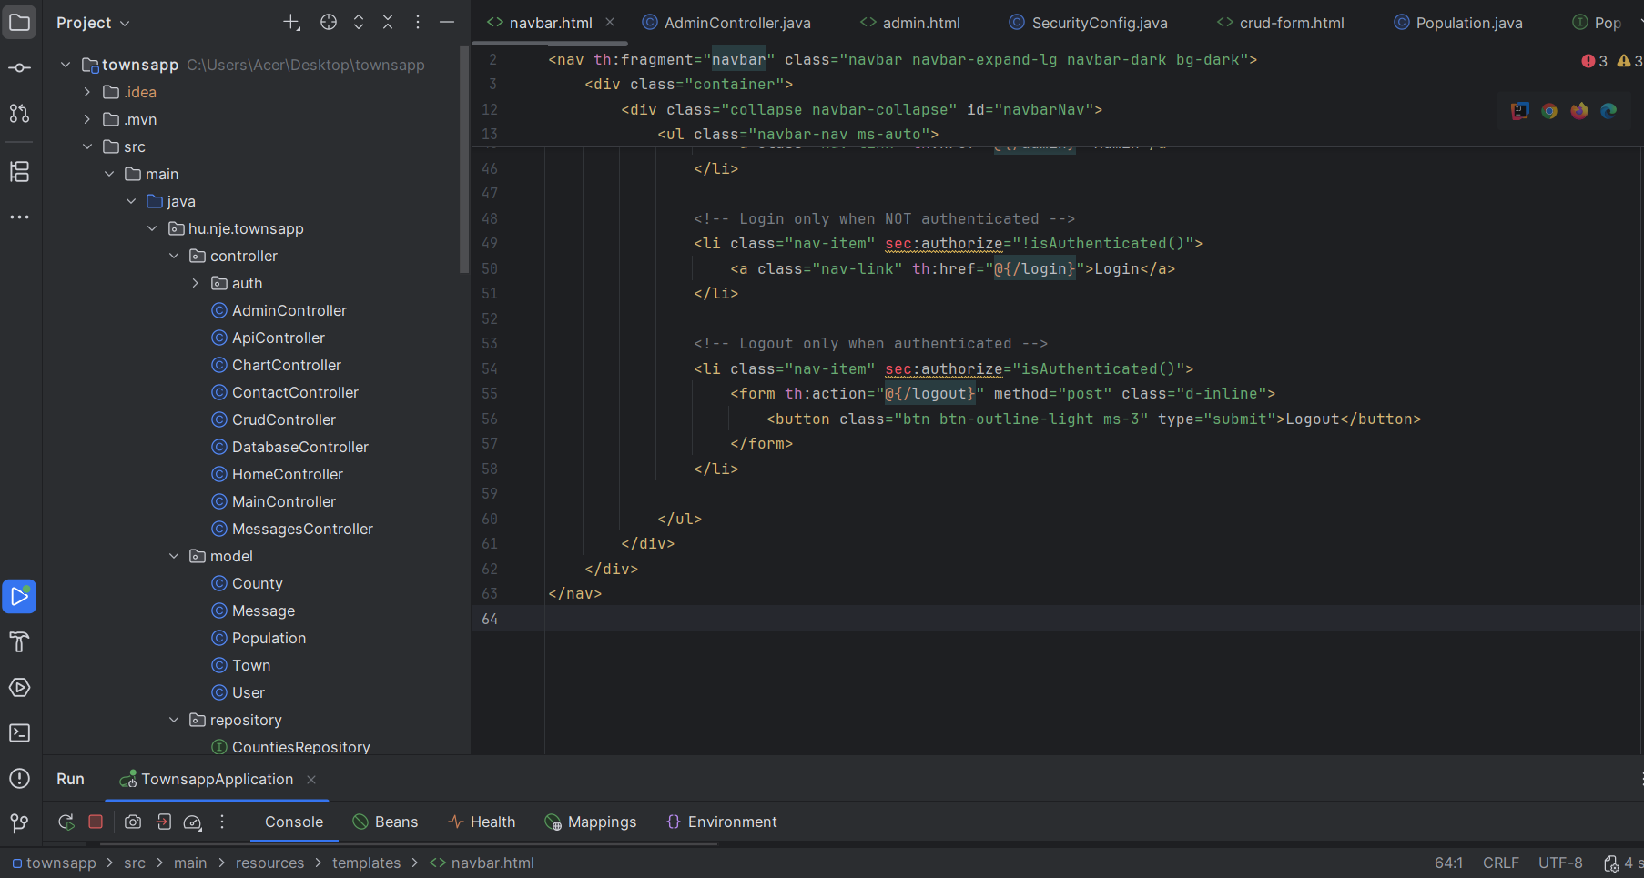

15. GitHub Repository
Your GitHub link goes here:
https://github.com/xaliyn/JAVABootstrap

